Wireshark Display Filters
The "Filter" toolbar

Note that display filters and capture filters don't have the same syntax,so you can't use most display filter expressions as capture filters.

Wireshark User's Guide - 6.3. Filtering packets while viewing
Wireshark User's Guide - 6.4. Building display filter expressions

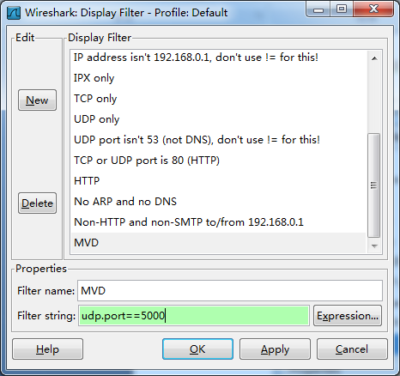
点击工具栏上的“Filter:”按钮，弹出以上“Display Filter Profile”，从中选择我们定义的Profile。
If you need a display filter for a specific protocol, have a look for it at the ProtocolReference.

Examples
Show only SMTP (port 25) and ICMP traffic:
- tcp.port eq 25 or icmp
- tcp.port==25 || icmp
Show only traffic in the LAN (192.168.x.x), between workstations and servers -- no Internet:
- ip.src==192.168.0.0/16 and ip.dst==192.168.0.0/16
TCP buffer full -- Source is instructing Destination to stop sending data
- tcp.window_size == 0 && tcp.flags.reset != 1
Filter on Windows -- Filter out noise, while watching Windows Client - DC exchanges
- smb || nbns || dcerpc || nbss || dns
Sasser worm: --What sasser really did--
- ls_ads.opnum==0x09
Match packets containing the (arbitrary) 3-byte sequence 0x81, 0x60, 0x03 at the beginning of the UDP payload, skipping the 8-byte UDP header. Note that the values for the byte sequence implicitly are in hexadecimal only. (Useful for matching homegrown packet protocols.)
- udp[8:3]==81:60:03(udp报文从第九字节开始（数据部分）的3个字节。)
- 检测tcp报文是否包含”GET /” (tcp报文从第20字节开始（数据部分）的5个字节。)
tcp[20:5] == 47:45:54:20:2f
tcp[20:5] == “\x47\x45\x54\x20\x2f”
tcp[20:5] == "GET /"
The "slice" feature is also useful to filter on the vendor identifier part (OUI) of the MAC address, see the Ethernet page for details. Thus you may restrict the display to only packets from a specific device manufacturer. E.g. for DELL machines only:
- eth.addr[0:3]==00:06:5B
It is also possible to search for characters appearing anywhere in a field or protocol by using the matches operator.
Match packets that contains the 3-byte sequence 0x81, 0x60, 0x03 anywhere in the UDP header or payload:
- udp contains 81:60:03
- 查看MPEG4视频帧
“tcp contains 00:00:01:b6”
“tcp contains “\x00\x00\x01\0xb6””
- 检测含有字符串"rtpOverHttp"的TCP报文
tcp contains "rtpOverHttp"
Match packets where SIP To-header contains the string "a1762" anywhere in the header:
- sip.To contains "a1762"
The matches operator makes it possible to search for text in string fields and byte sequences using a regular expression, using Perl regular expression syntax. Note: Wireshark needs to be built with libpcre in order to be able to use the matches operator.
Match HTTP requests where the last characters in the uri are the characters "gl=se":
- http.request.uri matches "gl=se$"($为正则表达式结尾符)
Note: The $ character is a PCRE punctuation character that matches the end of a string, in this case the end of http.request.uri field.
Filter by a protocol ( e.g. SIP ) and filter out unwanted IPs:
ip.src != xxx.xxx.xxx.xxx && ip.dst != xxx.xxx.xxx.xxx && sip
[ Feel free to contribute more ]

Gotchas
Some filter fields match against multiple protocol fields. For example, "ip.addr" matches against both the IP source and destination addresses in the IP header. The same is true for "tcp.port", "udp.port", "eth.addr", and others. It's important to note that
- ip.addr == 10.43.54.65
is equivalent to
ip.src == 10.43.54.65 or ip.dst == 10.43.54.65
This can be counterintuitive in some cases. Suppose we want to filter out any traffic to or from 10.43.54.65. We might try the following:
- ip.addr != 10.43.54.65
which is equivalent to
ip.src != 10.43.54.65 or ip.dst != 10.43.54.65
This translates to "pass all traffic except for traffic with a source IPv4 address of 10.43.54.65 and a destination IPv4 address of 10.43.54.65", which isn't what we wanted.
Instead we need to negate the expression, like so:
- ! ( ip.addr == 10.43.54.65 )
which is equivalent to
! (ip.src == 10.43.54.65 or ip.dst == 10.43.54.65)
This translates to "pass any traffic except with a source IPv4 address of 10.43.54.65 or a destination IPv4 address of 10.43.54.65", which is what we wanted.

